EXPERIMENT – 2
Name: B Mohith
Roll No: 2520030028
Section: 8
Title
File Copying Using Low-Level System Calls and System Call Tracing using strace
Aim
To implement a file-copy program using the low-level system calls open(), read(), write(), and close(), and trace the cat command using strace.
Theory
The open() system call is used to open a file, read() is used to read data from a file, write() is used to write data to a file, and close() is used to close an opened file. The strace command is used to trace the system calls made by a Linux command.
Algorithm
- Start the program.
- Open the source file using open().
- Open or create the destination file using open().
- Read data from the source file using read().
- Write the data into the destination file using write().
- Repeat the read and write operations until the entire file is copied.
- Close both files using close().
- Display the successful file-copy message.
- Trace the cat command using strace.
- Stop the program.
Code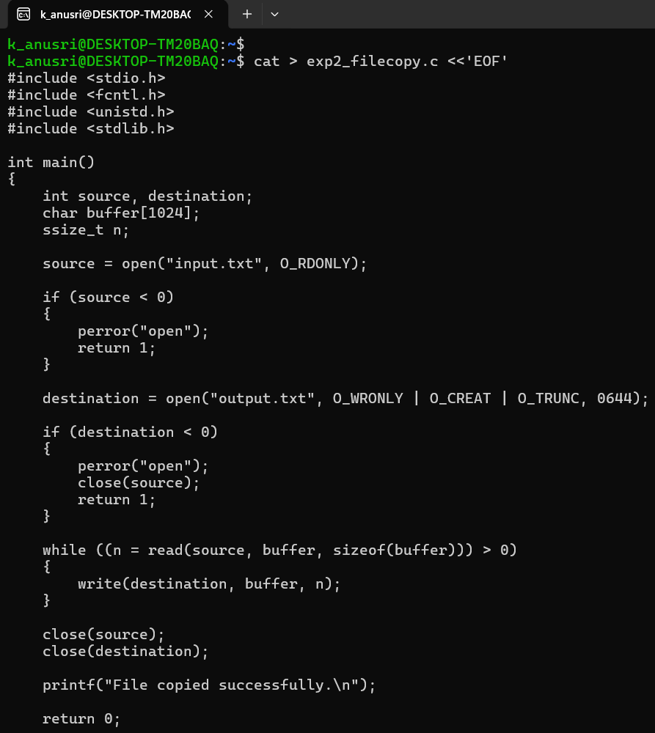
Execution Screenshots
Screenshot 1 — Create input file
Screenshot 2 — Compilation and execution
Screenshot 3 — Verify copied file
Screenshot 4 — strace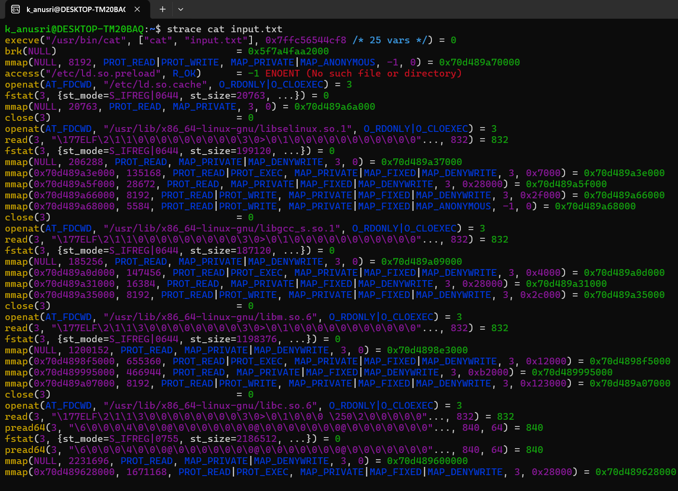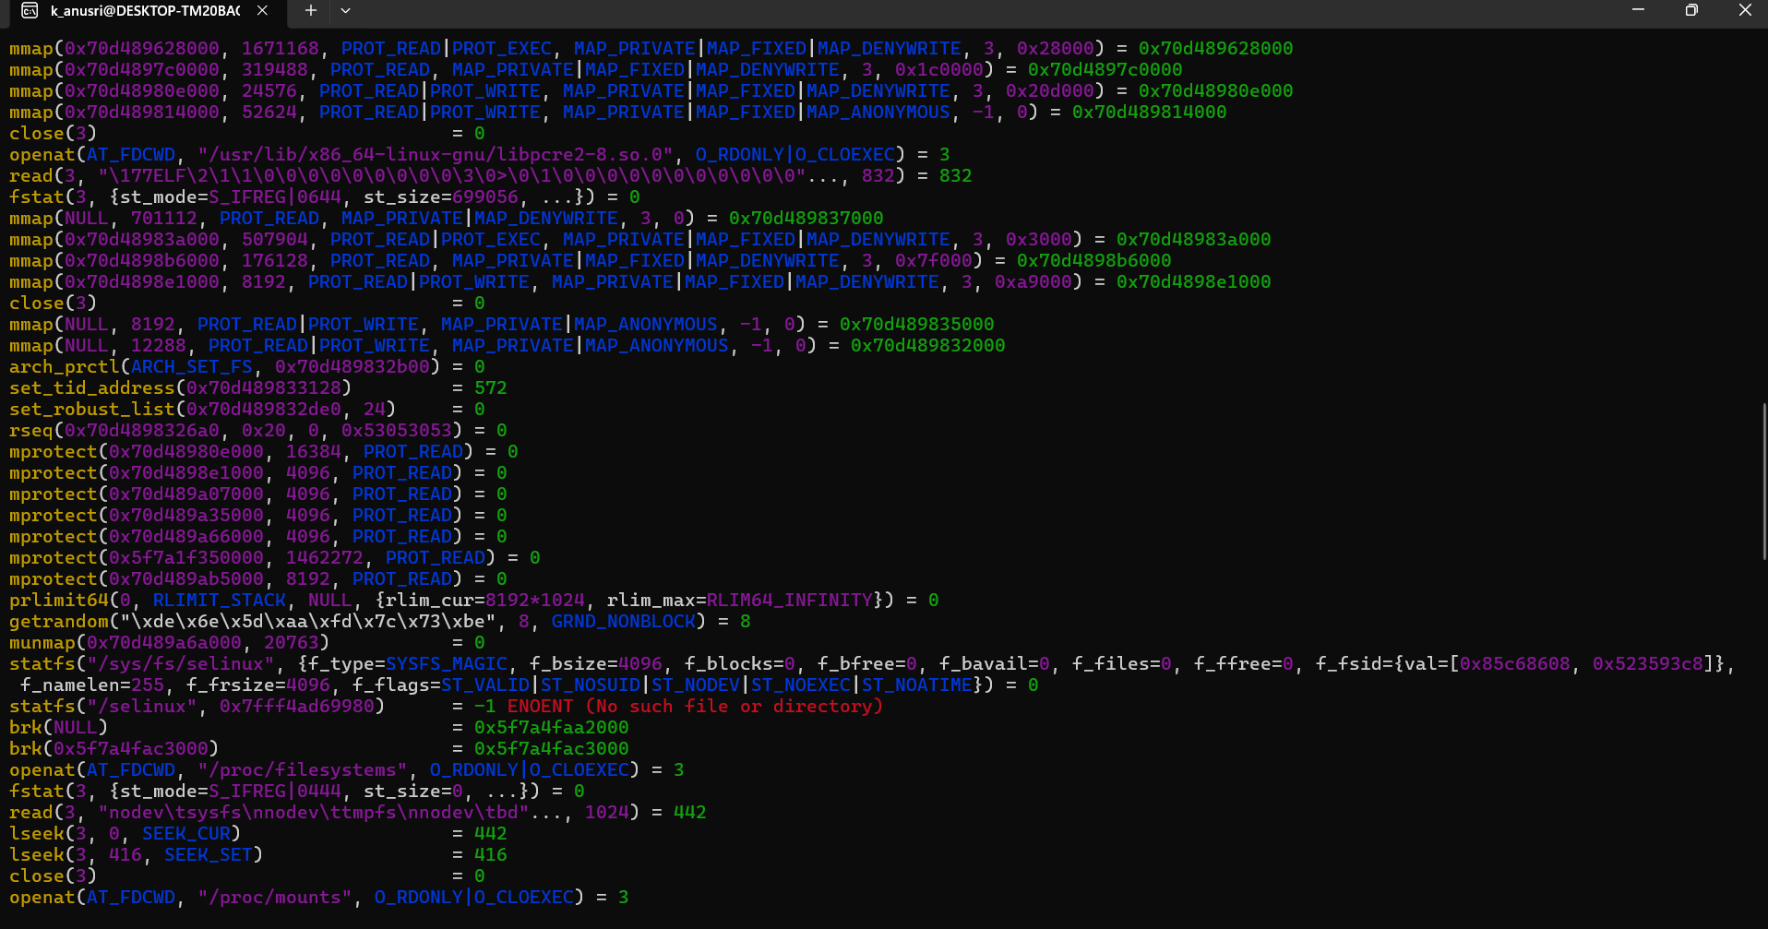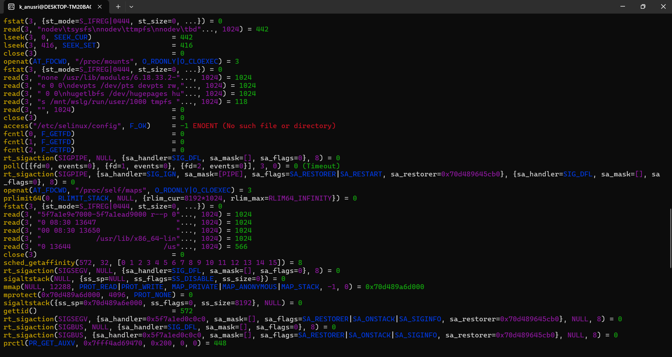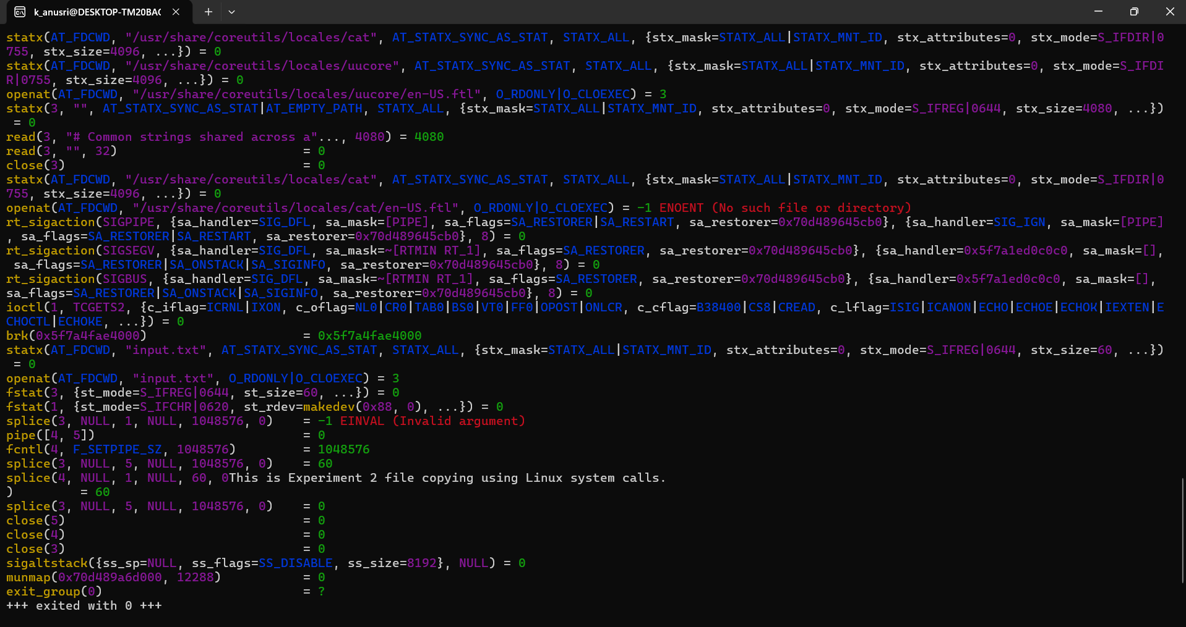
Result
The file was copied successfully using the low-level system calls open(), read(), write(), and close(). The system calls made by the cat command were traced successfully using strace.

